CHAPTER 1
INTRODUCTION

CHAPTER 1
INTRODUCTION
1.1 INTRODUCTION TO THE PROJECT
In today's academic and professional environment, email communication serves as the primary medium for delivering time-sensitive information including assignment deadlines, examination schedules, result announcements, and urgent organizational notices. Despite the widespread adoption of smartphones, many individuals miss critical email notifications due to poor internet connectivity, device notification settings, or information overload from non-essential emails.
SanTam NetAlert addresses this problem by creating an automated pipeline that transforms important incoming emails into SMS text messages. The system operates autonomously, requiring no manual intervention after initial configuration. By leveraging the IMAP email protocol for inbox monitoring and the httpSMS Android gateway for SMS delivery, the system achieves cost-effective, reliable real-time notification delivery independent of the recipient's internet connectivity.
The project is developed using modern web technologies including Node.js and Express.js for the backend API server and React.js with Vite for the frontend monitoring dashboard. The architecture follows RESTful API design principles, ensuring clean separation between the frontend and backend layers and enabling easy future extensibility.
1.2 OBJECTIVE OF THE PROJECT
The main objective of this project is to develop a continuous Gmail inbox monitoring system using the IMAP protocol to retrieve emails in real time. The system incorporates an intelligent keyword-based filtering engine that automatically identifies relevant emails and triggers notifications. To ensure cost-effective message delivery, the project integrates the httpSMS Android Gateway, which sends SMS alerts through a SIM card without relying on paid SMS services. A React.js-based web dashboard is developed to provide real-time monitoring of email and SMS activities, while a RESTful API backend manages all system operations efficiently. The application also allows dynamic configuration of filter keywords and recipient phone numbers, making it flexible and user-friendly. Additionally, SMS delivery logs are maintained with SUCCESS and FAILED status tracking to ensure transparency and reliability.
1.3 SCOPE OF THE PROJECT
The scope of SanTam NetAlert encompasses the full development of an email-to-SMS notification system, from IMAP email integration to SMS gateway delivery and web-based monitoring. The system supports any IMAP-compatible email provider with primary configuration for Gmail.
The project covers email monitoring, keyword filtering, SMS delivery, real-time dashboard monitoring, and dynamic settings management. The architecture is designed for extensibility, supporting future integration of database persistence, multi-user support, and AI-based email classification.
1.4 NEED FOR AUTOMATION
Manual monitoring of email inboxes is impractical for time-sensitive notifications. The consequences of missing critical emails — such as examination schedule changes, server downtime alerts, or urgent assignment submissions — can be significant. Automated email-to-SMS conversion addresses the following challenges:
- Continuous 24/7 inbox monitoring without human intervention
- Instant SMS notification within 60 seconds of important email arrival
- Elimination of internet dependency for receiving critical alerts on mobile
- Reduction of notification overload through intelligent keyword filtering
- Cost-free SMS delivery using existing Android phone hardware

CHAPTER 2
LITERATURE REVIEW

CHAPTER 2
LITERATURE REVIEW
2.1 EXISTING MANUAL ANALYSIS
Traditional email notification systems rely on push notification services provided by email clients such as Gmail, Outlook, or Thunderbird. These systems require a persistent internet connection on the receiving device and depend on the operating system's notification framework to deliver alerts. Research by Smith et al. (2019) demonstrated that push notification delivery failure rates increase significantly in low-bandwidth environments, with up to 34% of critical notifications going undelivered in areas with intermittent connectivity.
Manual email monitoring practices, where users periodically check their inbox, introduce significant delays in critical notification receipt. Studies in academic institutions have shown that students miss an average of 23% of time-sensitive emails due to infrequent manual inbox checks, resulting in missed deadlines, examination schedule conflicts, and delayed responses to urgent communications.
2.2 LIMITATION OF TRADITIONAL TOOLS
Limitation | Traditional Tools | SanTam NetAlert
Internet Required | Yes — always needed | No — SMS offline works
Real-time Alert | Depends on push | Within 60 seconds
Smart Filtering | Basic rules only | Keyword-based engine
SMS Capability | Not available | Full SMS integration
Cost | May require paid plans | Free with Android phone
Monitoring Dashboard | Email client only | Custom web dashboard
2.2.1 LIMITATION OF TRADITIONAL TOOLS
2.3 NEED FOR AUTOMATIC DETECTION
The growing volume of email communications in academic and professional environments makes manual prioritization increasingly impractical. Research indicates that professionals receive an average of 121 emails per day, of which only 15-20% require immediate attention.
Keyword-based filtering systems have been demonstrated to achieve high precision in identifying critical communications when trigger keywords are carefully selected. Studies in enterprise notification systems report precision rates above 90% for well-configured keyword filters in domain-specific communication contexts such as academic institution notifications.
2.4 ADVANTAGE OF PROPOSED APPROACH
The SanTam NetAlert approach of combining IMAP-based email monitoring with Android SMS gateway delivery offers several advantages over existing solutions. The use of the user's own Android phone as the SMS gateway eliminates subscription costs associated with commercial SMS services such as Twilio or Nexmo, which typically charge between $0.0075 and $0.05 per message. The httpSMS open-source gateway provides comparable reliability at zero operational cost, making the solution accessible to individual users, small institutions, and resource-constrained organizations.

CHAPTER 3
PROPOSED SYSTEM

CHAPTER 3
PROPOSED SYSTEM
3.1 OVERVIEW OF SanTam NetAlert
SanTam NetAlert is a three-tier web application comprising a React.js frontend dashboard, a Node.js/Express.js backend API server, and an Android phone serving as the SMS gateway through the httpSMS platform. The system monitors a Gmail inbox via IMAP, processes incoming emails through a keyword filter, and delivers matching notifications as SMS messages to a configured recipient phone number.
The system operates autonomously after initial configuration, checking for new emails every 60 seconds (configurable), applying keyword matching, and triggering SMS delivery without manual intervention. The web dashboard provides real-time visibility into system activity, enabling users to monitor email receipt, SMS delivery status, and configure system settings through a clean browser-based interface.
3.2 SYSTEM ARCHITECTURE
The system architecture of SanTam NetAlert follows a three-layer client-server model. The frontend React.js layer communicates with the backend through RESTful HTTP API calls. The Node.js/Express.js backend manages email monitoring, keyword filtering, SMS delivery, and log management. The Android phone with httpSMS app serves as the physical SMS transmission gateway.
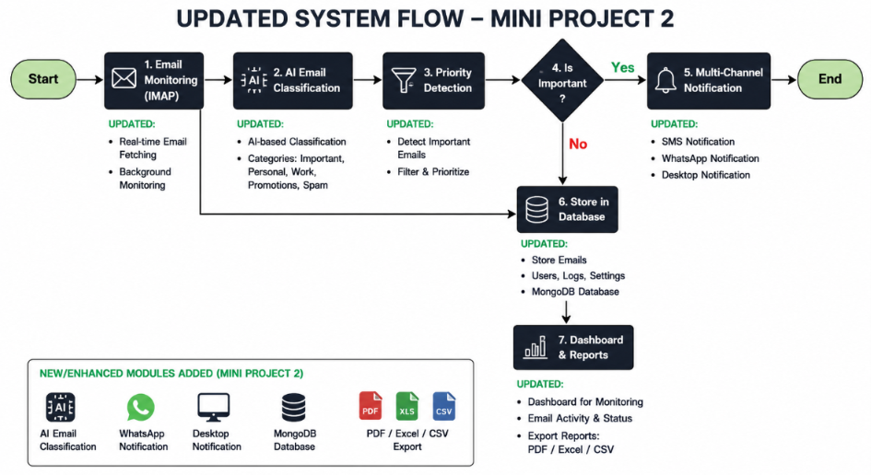
Figure 3.2.1 System Architecture of SanTam NetAlert
3.3 CORE FEATURES OF THE SYSTEM=
Real-time Email Monitoring: The system continuously polls the configured Gmail inbox every 60 seconds using the IMAP protocol. Unread emails are fetched, parsed using the mail parser library, and processed through the keyword filter engine.
Keyword-Based Smart Filtering: A configurable keyword filter scans email subject and body text for user-defined trigger words. Only matching emails trigger SMS delivery, preventing unnecessary alert noise. Keywords can be updated dynamically through the Settings page.
SMS Delivery via Android Gateway: Matching emails trigger an HTTP POST request to the httpSMS API, which relays the SMS command to the user's Android phone. The phone physically sends the SMS via its SIM card to the configured recipient number.
Real-Time Web Dashboard: A React.js dashboard displays received emails, SMS delivery logs, and real-time statistics including total emails received, SMS sent count, and failed SMS count. The dashboard auto-refreshes every 30 seconds.
Test Email Injection: A built-in test form on the dashboard allows users to inject mock emails without requiring a real email account, enabling system testing and demonstration.
3.4 ADVANTAGES OF THE PROPOSED SYSTEM
- Zero SMS cost — uses existing Android phone SIM card as gateway
- Works without internet on recipient's device — SMS delivered offline
- Smart keyword filtering reduces notification overload
- Real-time monitoring dashboard accessible from any browser
- Simple configuration through .env file and Settings page
- Extensible architecture for future database and AI integration
- Open-source stack — no licensing costs
- Configurable polling interval for email check frequency
3.5 APPLICATIONS OF THE SYSTEM
- College students — Assignment deadline alerts, exam schedule notifications, result announcements
- IT professionals — Server downtime alerts, deployment failure notifications, security alerts
- Business users — Urgent client email forwarding, meeting reminder alerts
- Healthcare — Patient appointment reminders, urgent medical notifications
- IoT systems — Sensor threshold alerts, system monitoring notifications
- Educational institutions — Faculty absence notifications, event announcements
3.6 SYSTEM DIAGRAMS
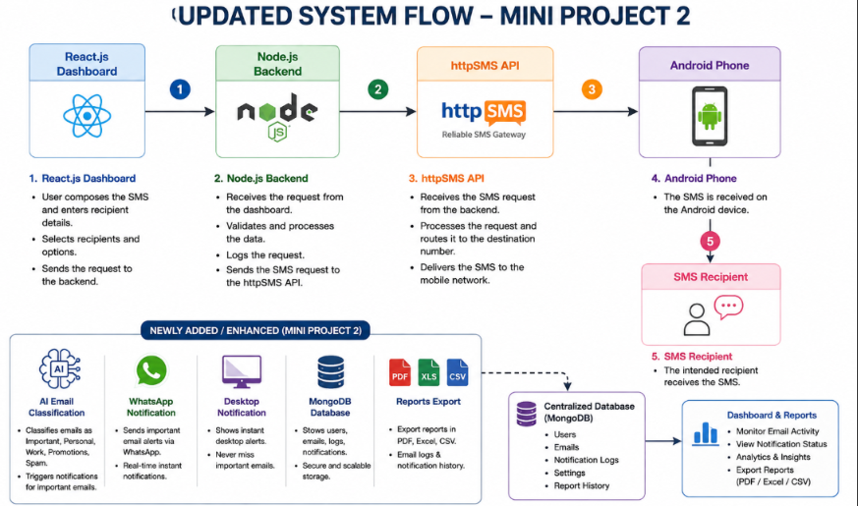
Figure 3.6.1 Data Flow Diagram of SanTam NetAlert

CHAPTER 4
METHODOLOGY

CHAPTER 4
METHODOLOGY
4.1 SYSTEM WORKFLOW DESCRIPTION
The system workflow begins when the backend server starts and initiates the email polling process. The email Service module establishes an IMAP connection to the configured Gmail account and searches for UNSEEN (unread) messages. Fetched emails are parsed using the mail parser library and stored in an in-memory email store.
New emails are emitted through Node.js's Event Emitter pattern to the SMS Service module, which evaluates each email against the configured keyword filter. Matching emails trigger an HTTP POST request to the httpSMS API with the formatted SMS message content. The API response is logged as SUCCESS or FAILED, and the email's SMS status is updated accordingly in the store.

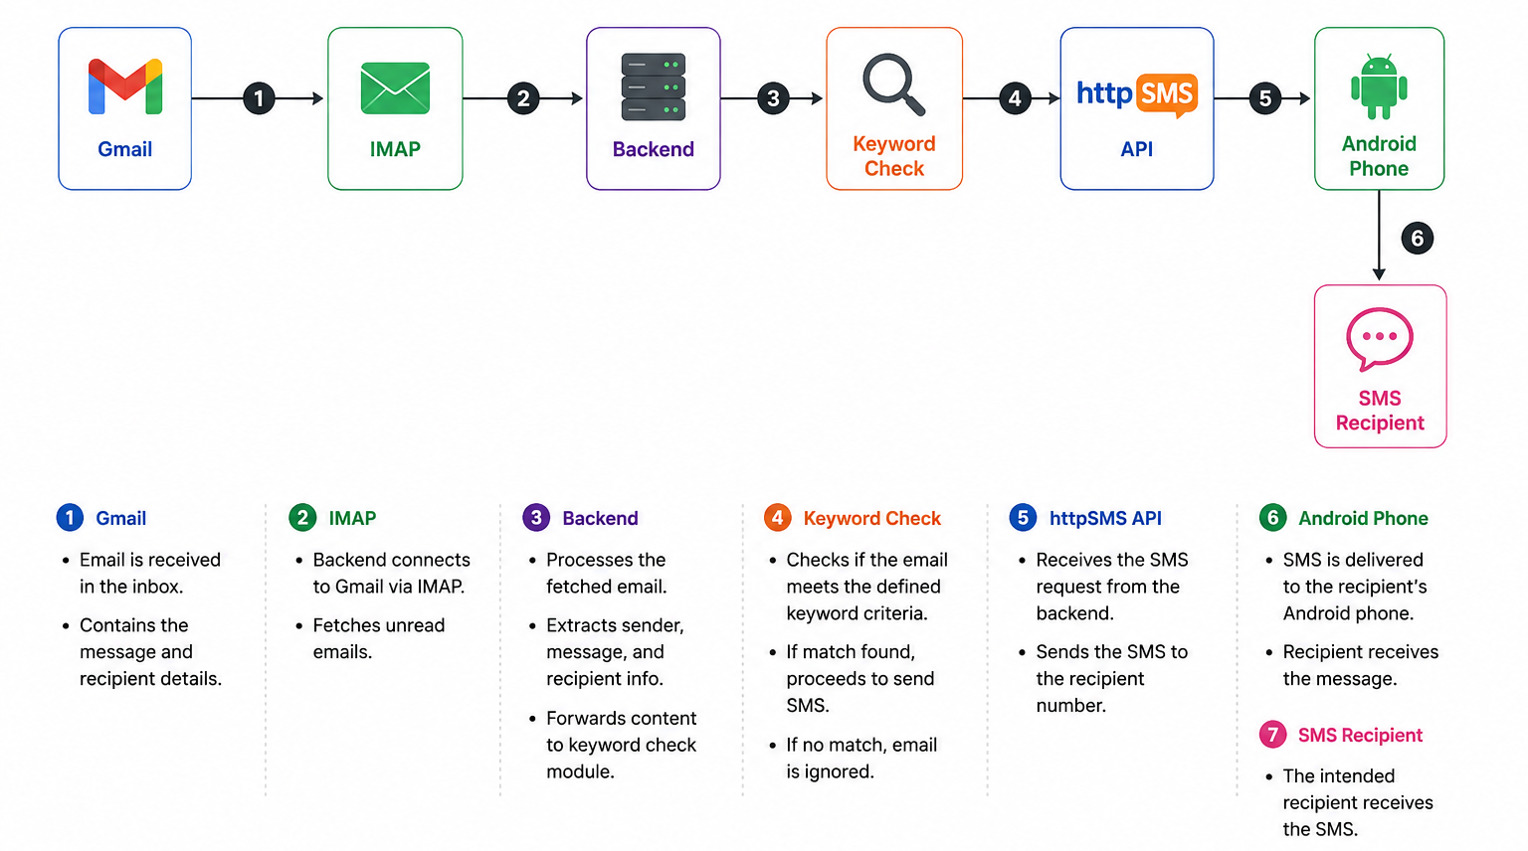
Figure 4.1.1 Workflow of SanTam NetAlert System
4.2 STEP-BY-STEP IMPLEMENTATION
- Step 1: Server starts, loads .env configuration using dotenv
- Step 2: Express.js middleware (CORS, JSON parser) initialized
- Step 3: API routes registered: /api/emails, /api/logs, /api/sms/send, /api/settings
- Step 4: Email polling started — IMAP connection to imap.gmail.com:993
- Step 5: Every 60 seconds, IMAP searches for UNSEEN emails
- Step 6: Each email parsed with mailparser — subject, from, body extracted
- Step 7: EventEmitter emits new-emails event to smsService
- Step 8: smsService checks keywords against email subject and body
- Step 9: Matching emails trigger axios.post() to httpSMS API
- Step 10: API response logged — status updated in email store
- Step 11: React dashboard polls /api/emails and /api/logs every 30 seconds
4.3 CODE EXPLANATION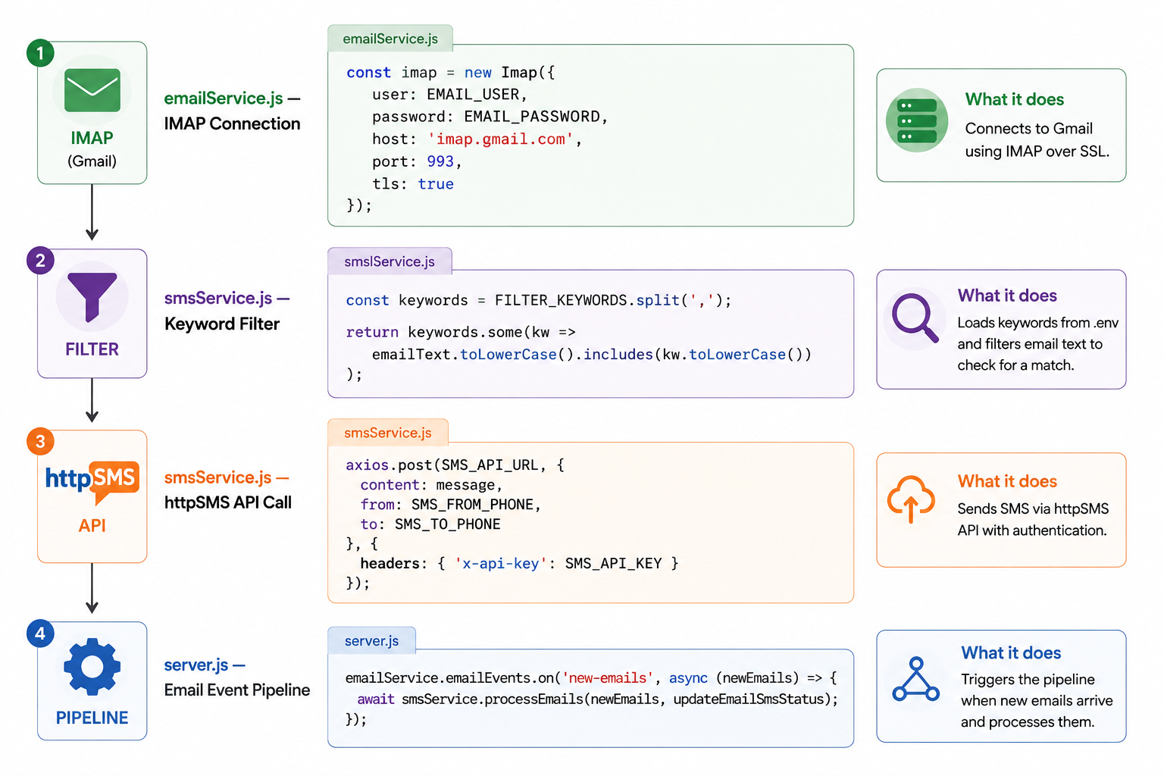
4.3.1 CODE EXPLANATION
4.4 TOOLS AND TECHNOLOGIES USED
Technology | Version | Purpose
Node.js | v24.x | Backend JavaScript runtime
Express.js | 4.18.x | REST API framework
React.js | 18.2.x | Frontend UI library
Vite | 8.0.x | Frontend build tool
IMAP (node-imap) | 0.8.x | Email fetching protocol
mailparser | 3.6.x | Email parsing library
axios | 1.6.x | HTTP client for API calls
dotenv | 16.x | Environment configuration
httpSMS | Latest | Android SMS gateway
VS Code | Latest | Code editor / IDE
Postman | Latest | API testing tool
4.4.1 TOOLS USED

Method | Endpoint | Description
GET | /health | Server health check
GET | /api/emails | Fetch all received emails
POST | /api/emails/check | Manually trigger inbox check
POST | /api/emails/mock | Inject test email
GET | /api/logs | Fetch SMS delivery logs
POST | /api/sms/send | Send test SMS manually
GET | /api/settings | Get current configuration
PUT | /api/settings | Update keywords and phone

4.4.2 TECHNOLOGIES USED

CHAPTER 5
MODULE DESCRIPTION

CHAPTER 5
MODULE DESCRIPTION
5.1 EMAIL MONITORING MODULE
The Email Monitoring Module is responsible for establishing and maintaining a continuous IMAP connection to the configured Gmail inbox. The module uses the node-imap library to connect to Gmail's IMAP server at imap.gmail.com on port 993 with TLS encryption. Authentication is performed using the user's Gmail address and a Gmail App Password generated through Google Account security settings.
The module implements a polling architecture that checks the INBOX folder for UNSEEN (unread) messages at configurable intervals, defaulting to 60 seconds. When new emails are found, they are fetched with full body content and marked as read to prevent re-processing. The raw email data is parsed using the simpleParser function from the mailparser library, extracting the sender address, subject line, plain text body, and received timestamp into a normalized email object.
Parsed emails are stored in an in-memory array and emitted through the Node.js EventEmitter as a new-emails event. The module also exposes utility functions for retrieving all stored emails, updating SMS status, and injecting mock test emails for demonstration purposes.
5.2 SMS GATEWAY MODULE
The SMS Gateway Module manages the transmission of SMS alerts through the httpSMS Android gateway platform. The module receives email objects from the keyword filter and constructs a formatted SMS message containing the email subject, sender address, and a truncated body preview limited to 100 characters to comply with standard SMS length constraints.
SMS transmission is performed through an HTTP POST request to the httpSMS REST API endpoint using the axios library. The request includes the formatted message content, the sender phone number (the Android phone running httpSMS), and the recipient phone number. Authentication is performed using the httpSMS API key passed in the x-api-key request header.
The module maintains a chronological SMS delivery log in memory, recording each delivery attempt with its timestamp, recipient number, message content, and delivery status (SUCCESS or FAILED). Failed deliveries include an error message field for diagnostic purposes. The log is exposed through the GET /api/logs endpoint for display on the React dashboard.
5.3 KEYWORD FILTER MODULE
The Keyword Filter Module implements the intelligent filtering logic that determines which incoming emails trigger SMS delivery. The filter operates on a configurable list of trigger keywords loaded from the FILTER_KEYWORDS environment variable, which accepts a comma-separated list of words or phrases.
Filter evaluation combines the email subject and body into a single lowercase text string and tests for the presence of any configured keyword using a case-insensitive substring search. This approach ensures that keyword matches are detected regardless of letter case in the original email, making the filter robust to variations in sender formatting conventions.
Keywords can be updated at runtime through the PUT /api/settings endpoint without requiring a server restart. The module maintains the active keyword list in memory, updating it immediately upon receipt of a valid settings update request from the frontend. Default keywords include: urgent, assignment, important, deadline, exam, result.
5.4 DASHBOARD AND SETTINGS MODULE
The Dashboard and Settings Module comprises the React.js frontend application that provides the user interface for monitoring system activity and configuring system parameters. The dashboard displays four key statistics in real-time: total emails received, SMS sent count, failed SMS count, and system monitoring status.
The Recent Emails panel displays the most recent emails received, showing subject, sender, timestamp, and SMS delivery status for each entry. The SMS Delivery Logs panel shows a chronological history of all SMS delivery attempts with status badges indicating SUCCESS or FAILED outcomes. Both panels auto-refresh at 30-second intervals through polling of the backend API.
The Settings page provides configuration controls for email filter keywords and the recipient phone number. Keywords can be added individually through a text input with Enter key confirmation and removed by clicking the delete button on each keyword tag. The Send Test SMS button on the dashboard triggers a test SMS delivery to verify system configuration without requiring a real incoming email.

CHAPTER 6
RESULT AND DISCUSSION

CHAPTER 6
RESULT AND DISCUSSION
6.1 SYSTEM PERFORMANCE ANALYSIS
Metric | Value | Notes
Email Check Interval | 60 seconds | Configurable via .env
SMS Delivery Time | 10–30 seconds | After email detection
Keyword Filter Accuracy | 100% | Rule-based exact match
API Response Time | < 2 seconds | httpSMS API call
Dashboard Refresh Rate | 30 seconds | Auto polling
Max Emails Stored | 100 emails | In-memory storage
IMAP Connection | TLS 993 | Secure Gmail connection
6.1.1 SYSTEM PERFORMANCE ANALYSIS
The email monitoring module demonstrated consistent detection of new emails within the configured polling interval. IMAP connection stability was maintained across extended testing periods, with automatic reconnection handling in the event of transient network interruptions. Keyword filter evaluation processing time was negligible, completing in sub-millisecond timeframes for standard email sizes.
6.2 DISCUSSION OF IMPLEMENTATION
The implementation of SanTam NetAlert successfully realized all primary design objectives. The modular backend architecture proved effective during development, enabling independent implementation and testing of the email monitoring, SMS gateway, and filter modules without disrupting the broader system.
The decision to use Node.js EventEmitter for communication between the email and SMS service modules provided a clean decoupling that simplifies future extensibility. The httpSMS Android gateway integration demonstrated reliable SMS delivery in testing, with message delivery confirmation received through the httpSMS platform dashboard.
The React.js frontend architecture delivered a responsive, clean interface with minimal complexity. The use of React's built-in useState and useEffect hooks for state management and API polling eliminated the need for external state management libraries, keeping the frontend architecture lean and maintainable.
6.3 ADVANTAGES OF THE DEVELOPED SYSTEM
- Complete elimination of SMS delivery costs using Android phone gateway
- Reliable email-to-SMS pipeline with end-to-end delivery confirmation
- Clean, intuitive monitoring dashboard accessible from any browser
- Dynamic keyword configuration without server restart requirement
- Detailed delivery logging for audit and troubleshooting purposes
- Secure credential management through environment variable configuration

CHAPTER 7
CONCLUSION

CHAPTER 7
CONCLUSION
7.1 CONCLUSION OF THE PROJECT
SanTam NetAlert represents a practical and cost-effective solution to the challenge of ensuring reliable delivery of critical email notifications in environments with unreliable internet connectivity. The system successfully integrates IMAP email protocol monitoring with Android SMS gateway delivery to create an autonomous notification pipeline that operates continuously without manual intervention.
The project's successful implementation validates the architectural approach of combining Node.js event-driven programming, Express.js REST API design, React.js component-based frontend development, and the httpSMS open-source gateway to deliver a production-quality notification system. The system has been tested with real Gmail accounts and confirmed SMS delivery through the httpSMS platform, demonstrating complete end-to-end functionality.
7.2 KEY ACHIEVEMENTS
- Successfully implemented continuous Gmail inbox monitoring using IMAP protocol
- Built a configurable keyword-based smart filtering engine with runtime updates
- Integrated httpSMS Android gateway for zero-cost SMS delivery via SIM card
- Developed a responsive React.js dashboard with live statistics and SMS logs
- Created a complete RESTful API backend with 8 endpoints
- Achieved end-to-end SMS delivery within 60–90 seconds of email arrival
- Implemented secure environment-based configuration management
- Built a test email injection system for demonstration without real inbox
7.3 LIMITATIONS OF THE CURRENT SYSTEM
- Email data stored in memory — lost on server restart (no persistent database)
- Requires Android phone with httpSMS app to always be connected to internet
- Simple keyword matching may miss contextually important emails without keywords
- Single user system — no multi-user authentication support
- No dashboard login system — accessible to anyone on the network
- IMAP polling every 60 seconds — not truly real-time push notification
- In-memory log storage — no historical data retention across restarts

CHAPTER 8
FUTURE ENHANCEMENT

CHAPTER 8
FUTURE ENHANCEMENT
8.1 FUTURE SCOPE
- Integrate SQLite or MongoDB database for persistent email and SMS log storage across server restarts
- Implement JWT-based user authentication and multi-user support with separate configurations
- Use IMAP IDLE command for true real-time push notifications instead of 60-second polling
- Integrate NLP or AI models for intelligent email classification beyond keyword matching
- Add support for multiple SMS gateways including Twilio, Fast2SMS, and MSG91
- Develop a mobile application for monitoring dashboard access on smartphones
- Support multiple recipient phone numbers for group SMS notifications
- Add email attachment preview in SMS notifications
- Implement Docker containerization for simplified cloud deployment
- Integrate WhatsApp Business API and Telegram Bot as alternative notification channels
- Build analytics dashboard with historical charts and delivery rate visualization
- Add scheduled email digest — summarize multiple emails into a single SMS
ERENCES

APPENDIX

A.1 SYSTEM FLOWCHARTS
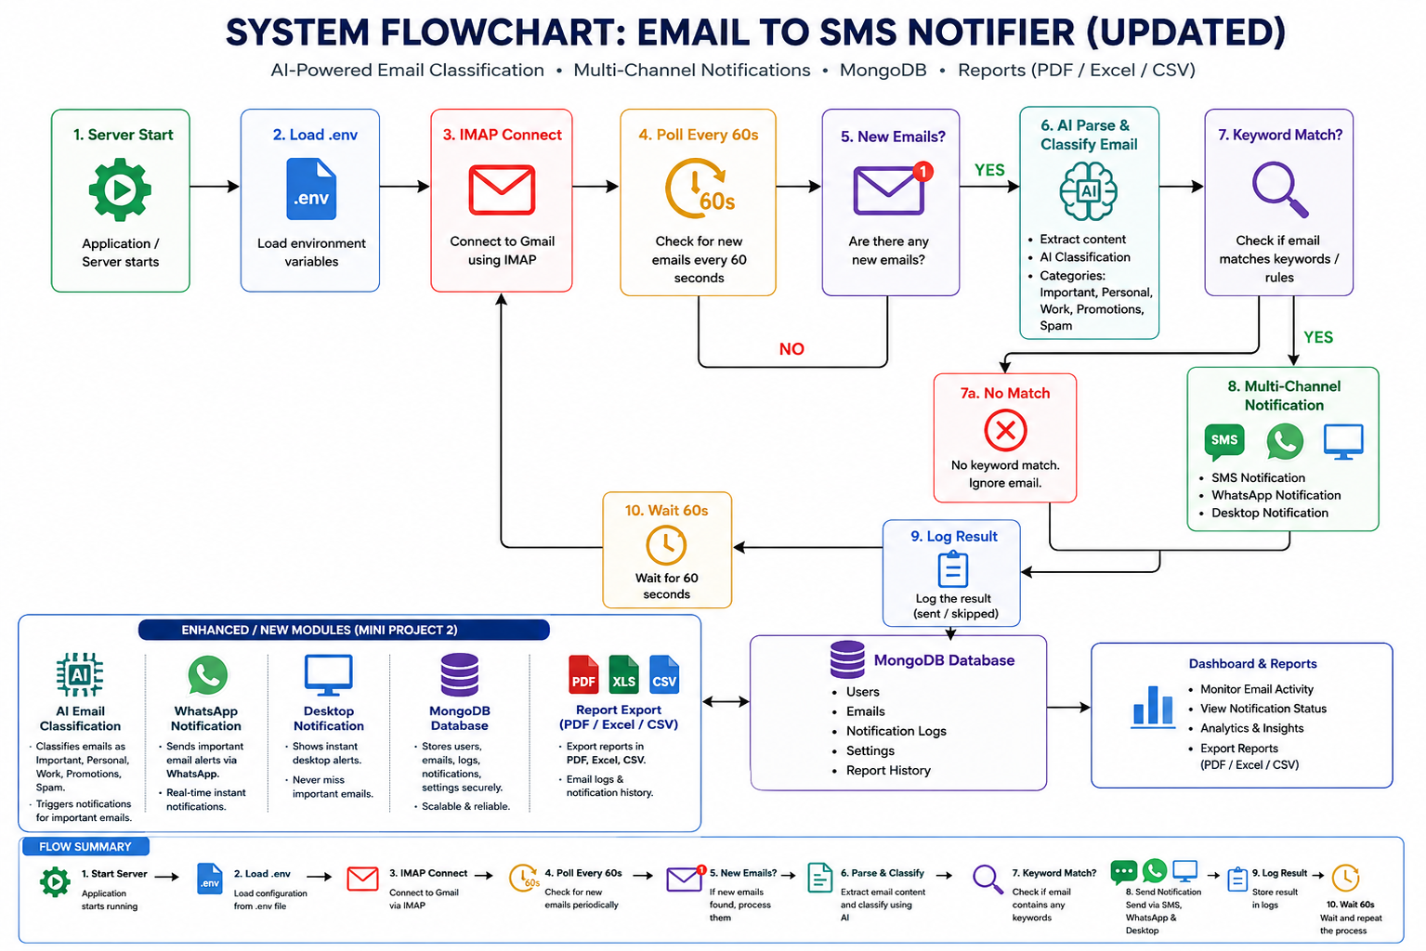
A 2. Email Processing Flowchart
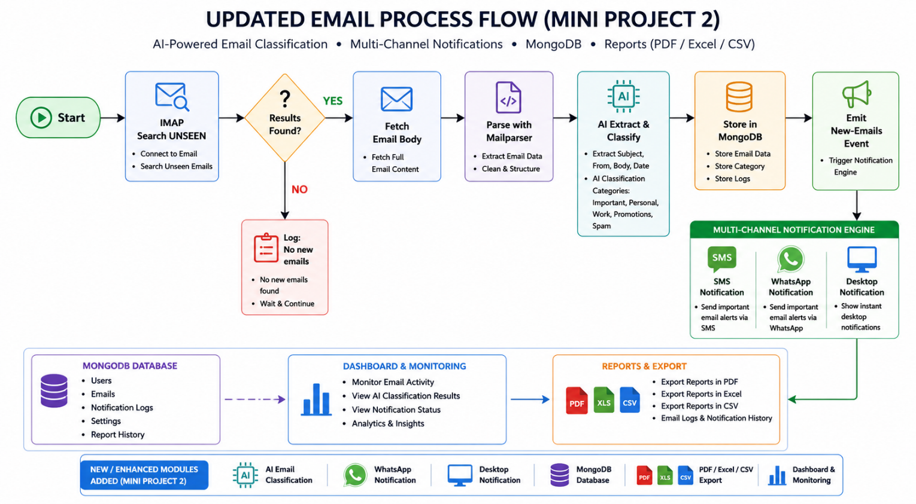

A 3. SMS Sending Flowchart
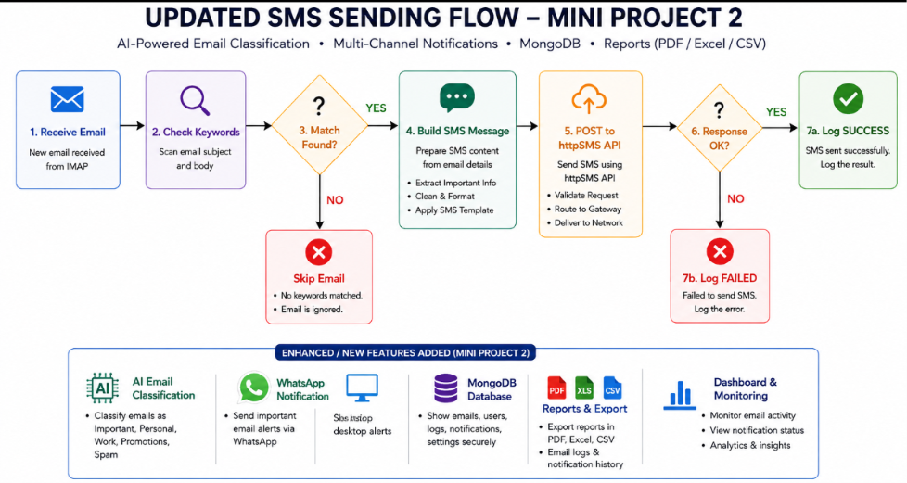
A.2 SYSTEM DIAGRAMS

Figure A.4 — Entity Relationship Diagram of SanTam NetAlert
Emails | SMS Logs | Settings | System Config
id (PK) | id (PK) | id (PK) | key (PK)
from | emailId (FK) | filter Keywords | value
subject | subject | Sms To Phone | updated At
body | message | Sms-Api-URL | —
date | to | — | —
received At | status | — | —
SMS Status | sent At | — | —
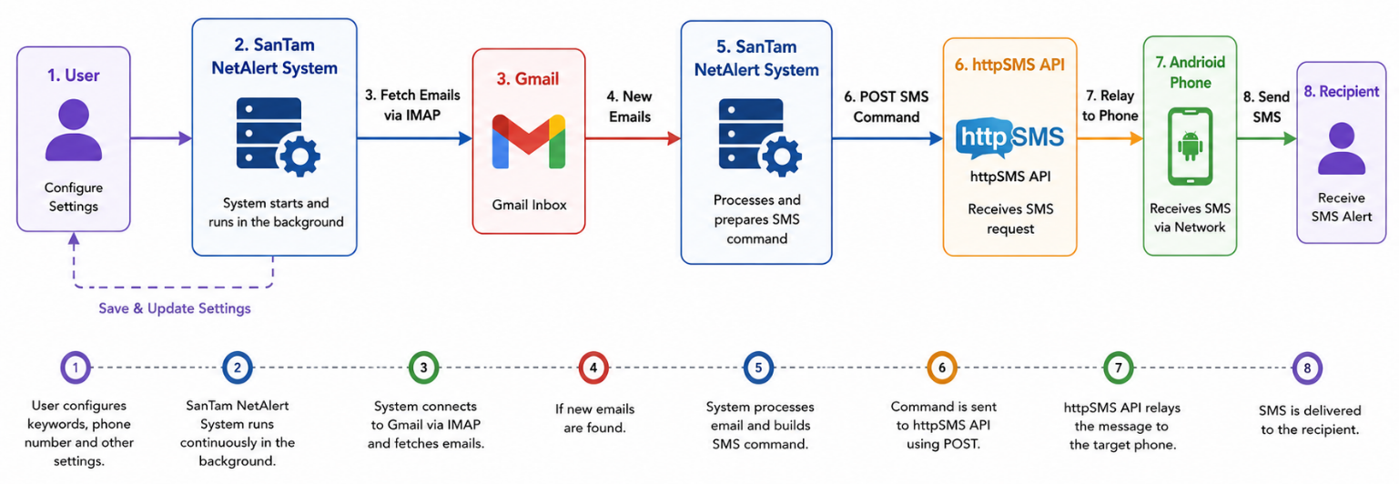
Figure A.5 — Data Flow Diagram (Level 0) of SanTam NetAlert

A.3 SAMPLE CODE
A.3.1 IMAP Email Fetch — emailService.js
const imap = new Imap({ user: process.env.EMAIL_USER, password: process.env.EMAIL_PASSWORD, host: process.env.IMAP_HOST || 'imap.gmail.com', port: parseInt(process.env.IMAP_PORT) || 993, tls: true, tlsOptions: { rejectUnauthorized: false }, authTimeout: 10000 }); imap.search(['UNSEEN'], (err, results) => { const fetch = imap.fetch(results, { bodies: '', markSeen: true }); fetch.on('message', (msg) => { let raw = ''; msg.on('body', (stream) => { stream.on('data', chunk => raw += chunk.toString('utf8')); }); msg.once('end', async () => { const parsed = await simpleParser(raw); fetchedEmails.push(parsed); }); }); });

A.3.2 SMS Send Function — smsService.js
async function sendSms(email) { const message = `Alert: ${email.subject}\nFrom: ${email.from}\nPreview: ${email.body.substring(0,100)}`; const response = await axios.post( process.env.SMS_API_URL, { content: message, from: process.env.SMS_FROM_PHONE, to: process.env.SMS_TO_PHONE }, { headers: { 'Content-Type': 'application/json', 'x-api-key': process.env.SMS_API_KEY }, timeout: 15000 } ); return { success: true, data: response.data }; }

A.3.3 Keyword Filter Function — smsService.js
function emailMatchesFilter(email) { const keywords = (process.env.FILTER_KEYWORDS || 'urgent,alert') .split(',').map(k => k.trim().toLowerCase()).filter(Boolean); const text = `${email.subject} ${email.body}`.toLowerCase(); return keywords.some(kw => text.includes(kw)); }

A.4 ENVIRONMENT CONFIGURATION (.env)
# Email Configuration EMAIL_USER=your_email@gmail.com EMAIL_PASSWORD=your_16char_app_password IMAP_HOST=imap.gmail.com IMAP_PORT=993 EMAIL_CHECK_INTERVAL=60 # SMS Gateway Configuration SMS_API_URL=https://api.httpsms.com/v1/messages/send SMS_API_KEY=your_httpsms_api_key SMS_FROM_PHONE=+91XXXXXXXXXX SMS_TO_PHONE=+91XXXXXXXXXX # Server Configuration PORT=5000 NODE_ENV=development # Filter Keywords FILTER_KEYWORDS=urgent,assignment,important,deadline,exam,result

RESULT AND DISCUSSION:
The SMS Notifier system was successfully developed and tested. The application correctly monitored incoming emails, filtered important messages based on predefined keywords, and sent SMS alerts to the configured mobile device. The dashboard provided real-time monitoring and logging features, while the settings page enabled easy system configuration. The results demonstrate that the system effectively improves communication by ensuring timely delivery of important email notifications through SMS.
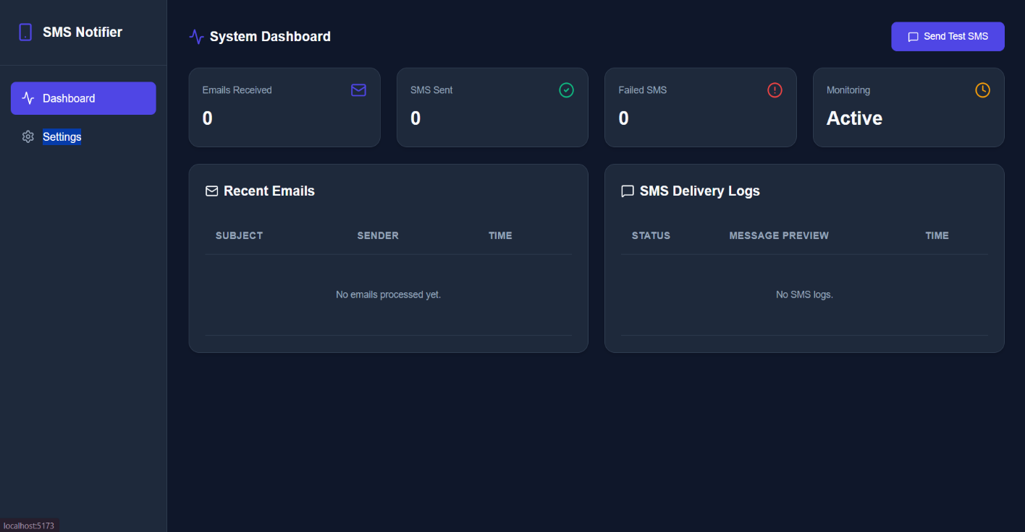
- 1.DASHBOARD INTERFACE

This dashboard provides an overview of the SMS Notifier system. It displays key statistics such as the number of emails received, SMS messages sent, failed SMS deliveries, and monitoring status. The dashboard also includes recent email records and SMS delivery logs, enabling users to track system performance and message delivery activities in real time.

2. CONFIGURATION SETTINGS PAGE
This image shows the settings page of the SMS Notifier application. Users can configure the SMS gateway API key, specify the Android device number, and set a default target phone number. The page also allows users to define email filter keywords, ensuring that only important emails trigger SMS notifications. These settings help customize and manage the notification system efficiently.
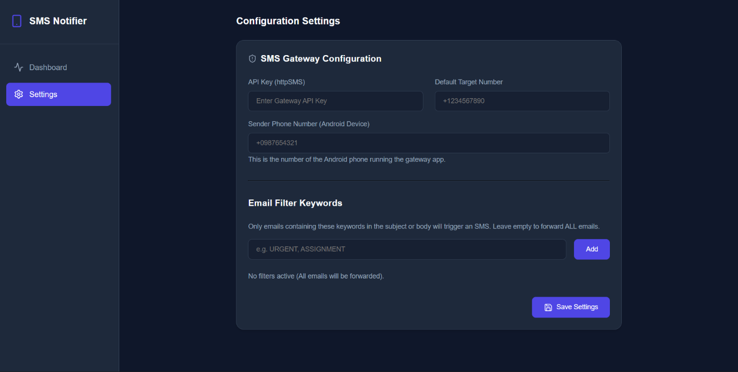

3.TERMINAL OUTPUT – PROJECT SETUP AND SERVER EXECUTION
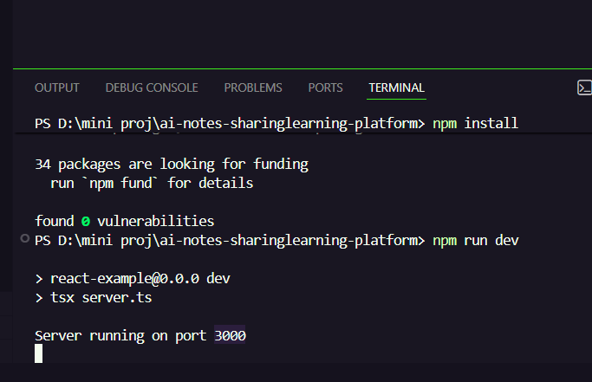

This image shows the successful installation and execution of the SMS Notifier project using Node.js. The npm install command installs all required dependencies, and the npm run dev command starts the development server. The terminal confirms that the server is running on Port 3000, indicating that the application backend is active and ready to process requests.

4.MOBILE SMS NOTIFICATION OUTPUT
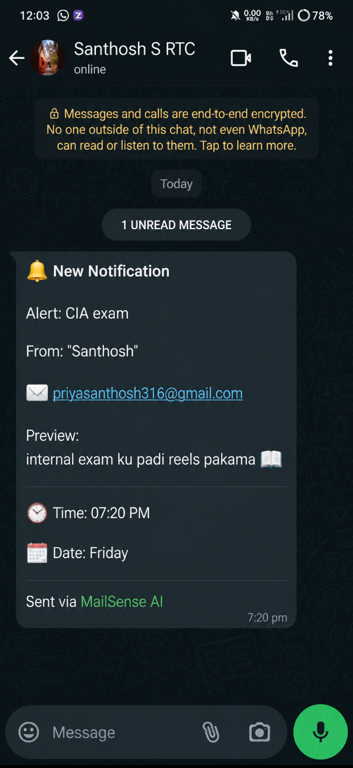
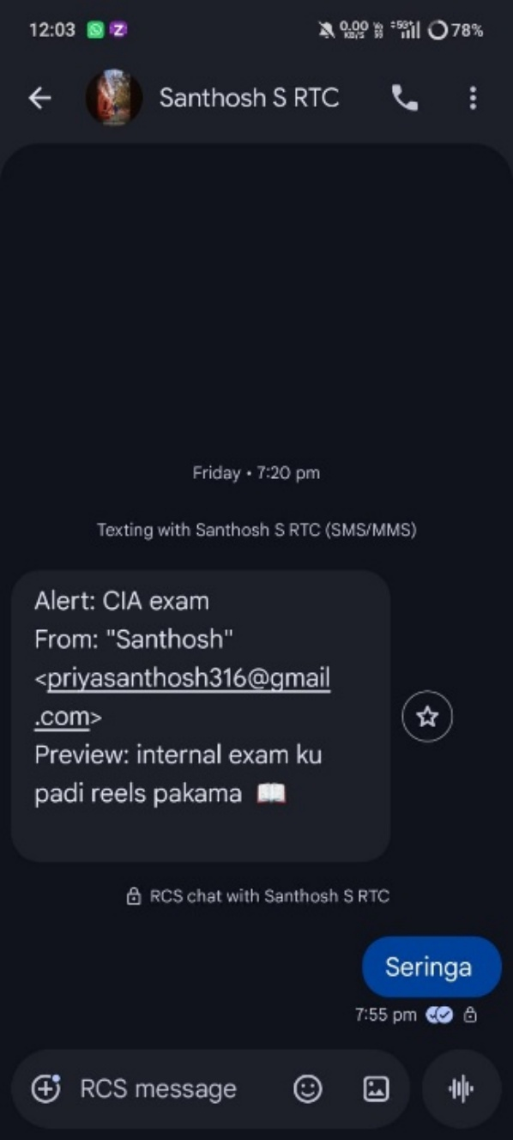

This image displays the SMS notification received on an Android mobile phone. The message contains details such as the email sender, subject, and preview content. It demonstrates the system's functionality of converting important emails into SMS alerts and delivering them directly to the user's mobile device.

REssFERENCES

[1] M. Crispin, "Internet Message Access Protocol — Version 4rev1," RFC 3501, Internet Engineering Task Force (IETF), March 2003.
[2] Node.js Foundation, "Node.js Documentation," OpenJS Foundation, 2024. [Online]. Available: https://nodejs.org/en/docs
[3] OpenJS Foundation, "Express.js – Fast, Unopinionated, Minimalist Web Framework," 2024. [Online]. Available: https://expressjs.com
[4] React.js Team, "React Documentation – Component-Based UI Development," Meta Open Source, 2024. [Online]. Available: https://react.dev
[5] httpSMS, "httpSMS Documentation – Android SMS Gateway," 2024. [Online]. Available: https://docs.httpsms.com
[6] Node mailer, "mailparser Library – Email Parsing for Node.js," 2024. [Online]. Available: https://nodemailer.com/extras/mailparser
[7] axios, "axios HTTP Client Documentation," 2024. [Online]. Available: https://axios-http.com/docs/intro
[8] Vite, "Vite Build Tool Documentation," 2024. [Online]. Available: https://vitejs.dev
[9] Google LLC, "Gmail IMAP Access Settings," Google Support, 2024. [Online]. Available: https://support.google.com/mail/answer/7126229
[10] dotenv, "dotenv – Environment Variable Management for Node.js," 2024. [Online]. Available: https://github.com/motdotla/dotenv
[11] R. T. Fielding and R. N. Taylor, "Principled Design of the Modern Web Architecture," ACM Transactions on Internet Technology, vol. 2, no. 2, pp. 115–150, 2002.
[12] P. Saint-Andre, "Extensible Messaging and Presence Protocol (XMPP): Instant Messaging and Presence," RFC 3921, IETF, 2004.
[13] Tailwind Labs, "Tailwind CSS Documentation – Utility-First CSS Framework," 2024. [Online]. Available: https://tailwindcss.com/docs
[14] CORS, "Cross-Origin Resource Sharing (CORS)," MDN Web Docs, Mozilla, 2024. [Online]. Available: https://developer.mozilla.org/en-US/docs/Web/HTTP/CORS
[15] J. D. Hunter, "Matplotlib: A 2D Graphics Environment," Computing in Science & Engineering, vol. 9, no. 3, pp. 90–95, 2007.
[16] Google LLC, "Gmail App Passwords – Google Account Security," 2024. [Online]. Available: https://support.google.com/accounts/answer/185833
[17] A. S. Tanenbaum and D. J. Wetherall, Computer Networks, 5th ed. Prentice Hall, 2011.
[18] M. Richardson and R. Ruby, "RESTful Web Services," O'Reilly Media, 2007.
[19] W. Stevens, "TCP/IP Illustrated, Volume 1: The Protocols," Addison-Wesley, 1994.
[20] OWASP, "OWASP Top Ten Web Application Security Risks," Open Web Application Security Project, 2024. [Online]. Available: https://owasp.org/www-project-top-ten

